**Target Business Case Study**

**🛒 Target Brazil E-Commerce Case Study**

**📌 Project Overview**

Analyzed 100,000+ e-commerce orders from Target Brazil (2016–2018) to uncover operational insights across order processing, pricing, payments, freight, customer behavior, and delivery performance.

**🎯 Objectivess**

As a data analyst at Target, the goal was to extract actionable insights from a multi-table dataset and recommend improvements in logistics, pricing, and customer experience.

**📂 Dataset Summary**

* Source: [Google Drive Folder](https://drive.google.com/drive/folders/1TGEc66YKbD443nslRi1bWgVd238gJCnb)
* Format: 8 CSV files
* Tables: orders, order_items, customers, sellers, payments, reviews, products, geolocation

**🔍 Key Explorations & Insights**

**🧭 Exploratory Analysis**

* Identified data types and structure across all tables
* Mapped customer distribution by city and state
* Extracted order time range and seasonal patterns

**📈 Order Trends**

* Analyzed yearly and monthly growth in order volume
* Segmented order times into Dawn, Morning, Afternoon, Night
* Tracked monthly order counts per state

**💰 Economic Impact**

* Calculated % increase in payment value from Jan–Aug (2017 vs 2018)
* Aggregated total & average order price and freight by state

**🚚 Delivery Performance**

* Computed delivery time and deviation from estimated delivery
* Ranked states by:
* Highest/lowest average freight cost
* Fastest/slowest delivery time
* Most efficient delivery vs estimated date

**💳 Payment Analysis**

* Monthly breakdown of payment types used
* Distribution of orders by installment count

**🛠️ Tools & Skills Used**

* Python (pandas, NumPy, Seaborn)
* Data cleaning & transformation
* Time-series analysis
* Geo-mapping & state-level aggregation
* Business storytelling with data

--------------------------------------------------------------

**Import the dataset and do the usual exploratory analysis steps like checking the structure & characteristics of the dataset:**

**1. Data type of all columns in the "customers" table.**

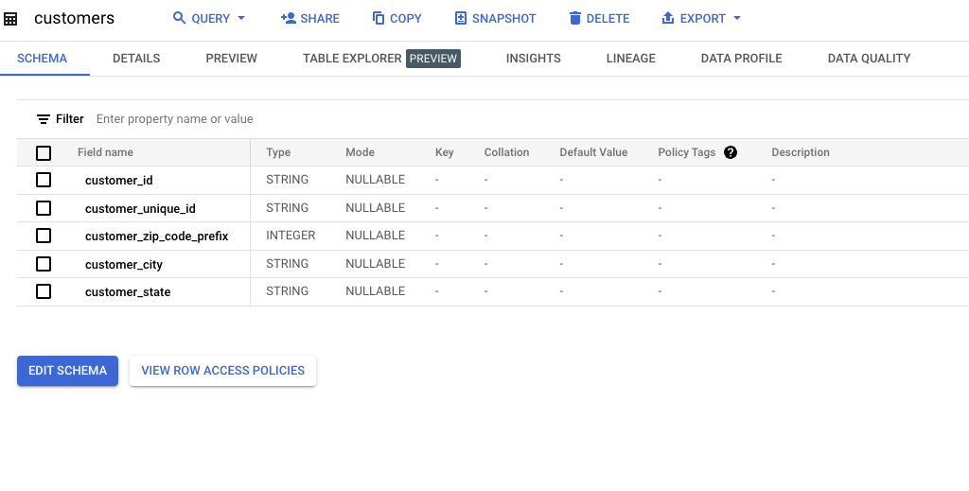

**2. Get the time range between which the orders were placed.**

SELECT MIN(order_purchase_timestamp) AS order_start_date,

MAX(order_purchase_timestamp) AS order_end_date,

FROM `TARGET_SQL.orders`

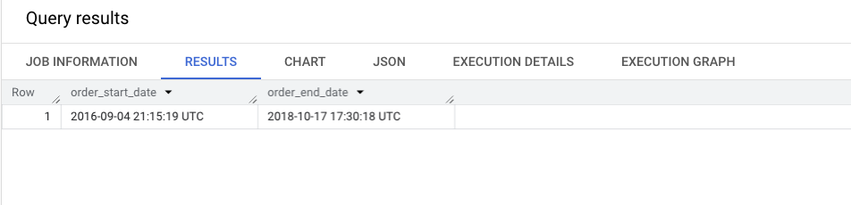

**3. Count the Cities & States of customers who ordered during the given period.**

WITH min_max_dates AS (

SELECT

MIN(order_purchase_timestamp) AS min_date,

MAX(order_purchase_timestamp) AS max_date

FROM `TARGET_SQL.orders`

)

SELECT COUNT(DISTINCT cust.customer_id) AS cities_state_count

FROM `TARGET_SQL.customers` AS cust

JOIN `TARGET_SQL.orders` AS ord

ON cust.customer_id = ord.customer_id

JOIN min_max_dates AS dates

ON ord.order_purchase_timestamp BETWEEN dates.min_date AND dates.max_date;

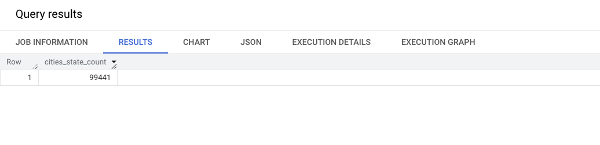

**----------------------------------------------------------------------------------------------------------**

**In-depth Exploration:**

**1. Is there a growing trend in the no. of orders placed over the past years?**

WITH order_data AS (

SELECT

order_id,

order_purchase_timestamp,

FORMAT_DATETIME('%Y-%m', order_purchase_timestamp) AS past_years

FROM `TARGET_SQL.orders`

)

SELECT

past_years,

COUNT(*) AS order_month_count,

COUNT(*)-LAG(COUNT(*)) OVER(ORDER BY past_years) AS growth_trend

FROM order_data

GROUP BY past_years

ORDER BY past_years

LIMIT 10

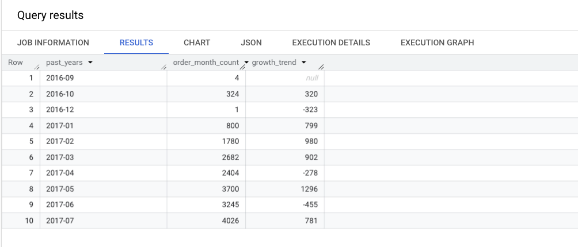

**2. Can we see some kind of monthly seasonality in terms of the no. of orders being placed?**

WITH order_data AS (

SELECT

FORMAT_DATETIME('%m', order_purchase_timestamp) AS past_month,

COUNT(order_id) AS order_month_count

FROM `TARGET_SQL.orders`

GROUP BY past_month

)

SELECT

past_month,

AVG(order_month_count) OVER() AS avg_month_count,

order_month_count - ROUND(AVG(order_month_count) OVER(), 2) AS monthly_seasonal

FROM order_data

ORDER BY past_month

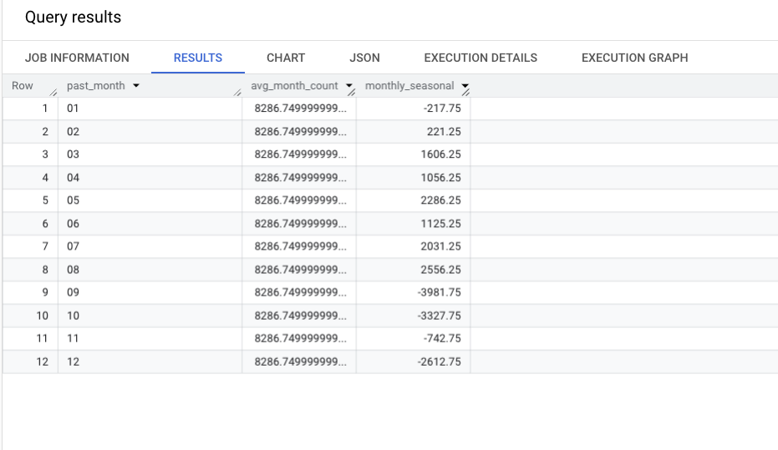

**3. During what time of the day, do the Brazilian customers mostly place their orders? (Dawn, Morning, Afternoon or Night)**

* + **0-6 hrs : Dawn**
  + **7-12 hrs : Mornings**
  + **13-18 hrs : Afternoon**
  + **19-23 hrs : Night**

SELECT order_purchase_timezone, count(order_purchase_timezone) FROM (

SELECT order_purchase_timestamp,

CASE

WHEN extract(hour FROM order_purchase_timestamp) between 0 and 6 THEN 'Dawan'

WHEN extract(hour FROM order_purchase_timestamp) between 7 and 12 THEN 'Mornings'

WHEN extract(hour FROM order_purchase_timestamp) between 13 and 18 THEN 'Afternoon'

ELSE 'Night'

END AS order_purchase_timezone

FROM `TARGET_SQL.orders`)

GROUP BY order_purchase_timezone

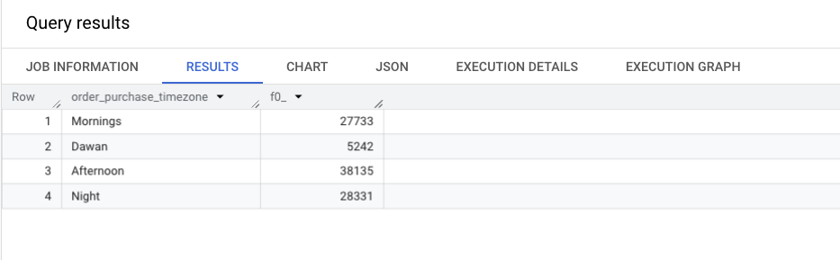

-------------------------------------------------------------------------------------------------------------------------------------------------------

**Evolution of E-commerce orders in the Brazil region:**

**1. Get the month on month no. of orders placed in each state.**

SELECT geo.geolocation_state,

extract(month FROM ord.order_purchase_timestamp) AS order_month,

count(ord.order_id) AS month_on_month

FROM `TARGET_SQL.geolocation` AS geo

JOIN `TARGET_SQL.customers` AS cust

ON geo.geolocation_zip_code_prefix = cust.customer_zip_code_prefix

JOIN `TARGET_SQL.orders` AS ord

ON cust.customer_id = ord.customer_id

GROUP BY geo.geolocation_state, order_month

order by geo.geolocation_state, order_month

limit 15

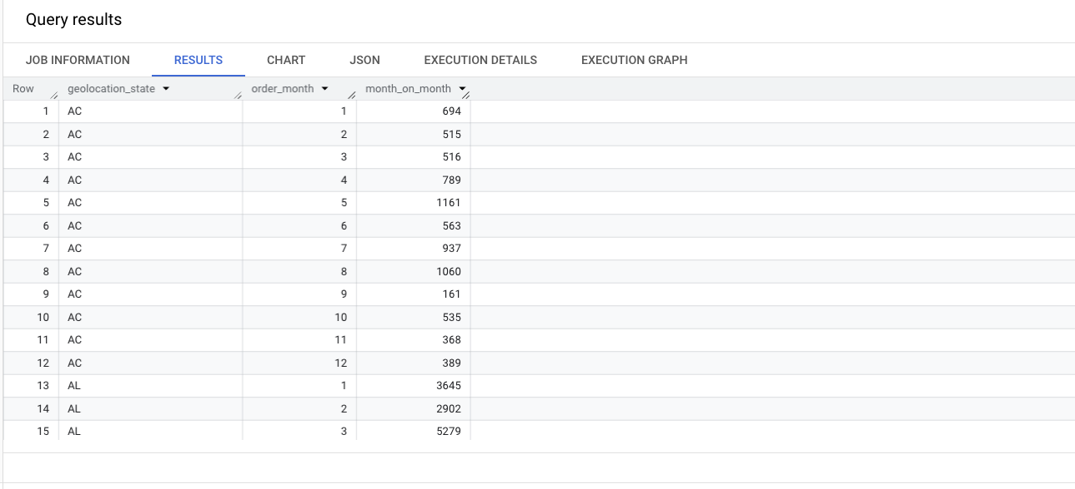

**2. How are the customers distributed across all the states?**

SELECT geo.geolocation_state,count(distinct cust.customer_id) AS no_customers

FROM `TARGET_SQL.geolocation` AS geo

JOIN `TARGET_SQL.customers` AS cust

ON geo.geolocation_zip_code_prefix = cust.customer_zip_code_prefix

GROUP BY geo.geolocation_state

limit 10

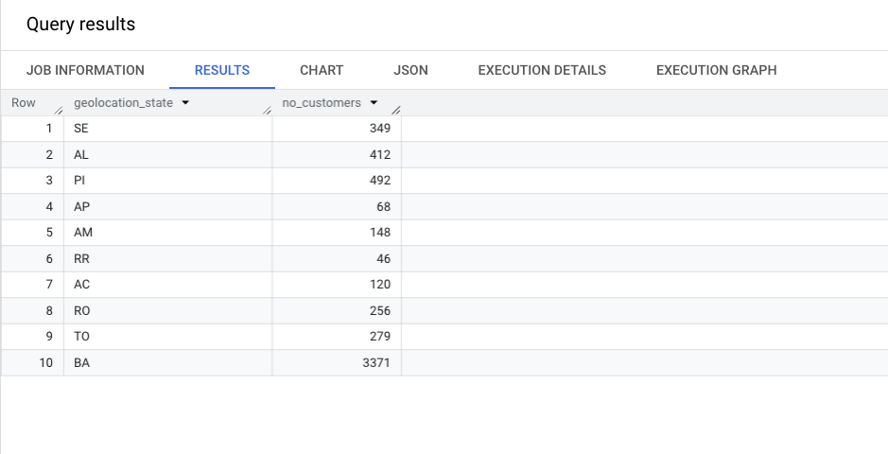

---------------------------------------------------------------------------------------------------------------------------------------------------------

**Impact on Economy: Analyze the money movement by e-commerce by looking at order prices, freight and others.**

**1.Get the % increase in the cost of orders from year 2017 to 2018 (include months between Jan to Aug only).**

WITH monthly_avg_payment AS (

SELECT

EXTRACT(YEAR FROM ord.order_purchase_timestamp) AS year_x,

EXTRACT(MONTH FROM ord.order_purchase_timestamp) AS month_x,

AVG(pmt.payment_value) AS avg_payment

FROM `TARGET_SQL.orders` AS ord

JOIN `TARGET_SQL.payments` AS pmt

ON ord.order_id = pmt.order_id

WHERE EXTRACT(YEAR FROM ord.order_purchase_timestamp) IN (2017, 2018)

AND EXTRACT(MONTH FROM ord.order_purchase_timestamp) BETWEEN 1 AND 8

GROUP BY year_x, month_x

)

SELECT

year_x,

month_x,

avg_payment,

ROUND(

(avg_payment - LAG(avg_payment) OVER (ORDER BY year_x, month_x)) * 100

/ LAG(avg_payment) OVER (ORDER BY year_x, month_x), 2) AS percentage_increase

FROM monthly_avg_payment

ORDER BY year_x, month_x;

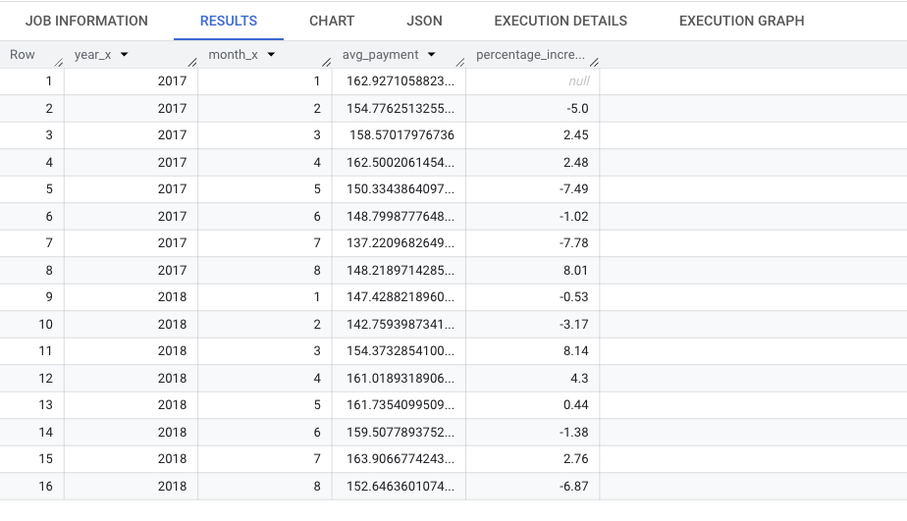

**2. Calculate the Total & Average value of order price for each state.**

SELECT

geo.geolocation_state,

SUM(pmt.payment_value) AS total_price,

AVG(pmt.payment_value) AS avg_price

FROM `TARGET_SQL.geolocation` AS geo

JOIN `TARGET_SQL.customers` AS cust

ON geo.geolocation_zip_code_prefix = cust.customer_zip_code_prefix

JOIN `TARGET_SQL.orders` AS ord

ON ord.customer_id = cust.customer_id

JOIN `TARGET_SQL.payments` AS pmt

ON ord.order_id = pmt.order_id

GROUP BY geo.geolocation_state

ORDER BY total_price DESC

LIMIT 10;

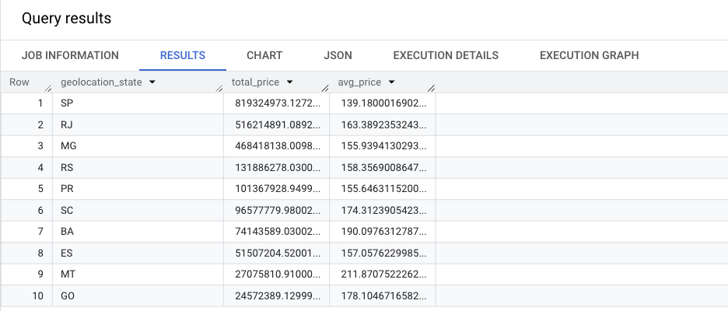

**3. Calculate the Total & Average value of order freight for each state.**

SELECT

geo.geolocation_state,

SUM(orditm.freight_value) as total_freight_value,

AVG(orditm.freight_value) as avg_freight_value

FROM `TARGET_SQL.order_items` AS orditm

JOIN `TARGET_SQL.orders` AS ord

ON orditm.order_id = ord.order_id

JOIN `TARGET_SQL.customers` AS cust

ON ord.customer_id = cust.customer_id

JOIN `TARGET_SQL.geolocation` AS geo

ON cust.customer_zip_code_prefix = geo.geolocation_zip_code_prefix

GROUP BY geo.geolocation_state

LIMIT 10

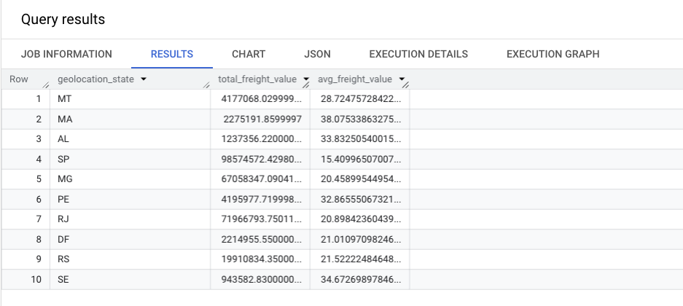

**-------------------------------------------------------------------------------------------------------------**

**Analysis based on sales, freight and delivery time.**

**A. Find the no. of days taken to deliver each order from the order’s purchase date as delivery time.  
Also, calculate the difference (in days) between the estimated & actual delivery date of an order.  
Do this in a single query.  
  
You can calculate the delivery time and the difference between the estimated & actual delivery date using the given formula:**

* + **time_to_deliver = order_delivered_customer_date - order_purchase_timestamp**
  + **diff_estimated_delivery = order_delivered_customer_date - order_estimated_delivery_date**

SELECT

order_id,

customer_id,

date_diff(order_delivered_customer_date, order_purchase_timestamp, day) as time_to_deliver,

date_diff(order_delivered_customer_date, order_estimated_delivery_date, day) as diff_estimated_delivery

FROM `TARGET_SQL.orders`

WHERE order_delivered_customer_date IS NOT NULL

LIMIT 10;

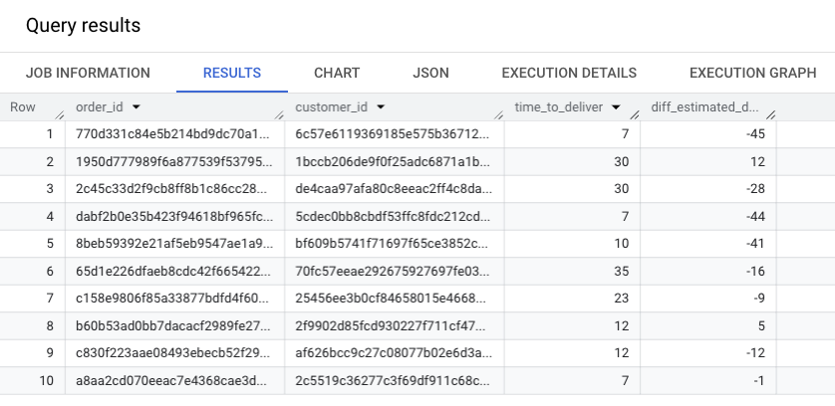

**2. Find out the top 5 states with the highest & lowest average freight value.**

WITH freight_value AS(

SELECT

geo.geolocation_state as state,

AVG(orditm.freight_value) as avg_freight_value

FROM `TARGET_SQL.order_items` AS orditm

JOIN `TARGET_SQL.orders` AS ord

ON orditm.order_id = ord.order_id

JOIN `TARGET_SQL.customers` AS cust

ON ord.customer_id = cust.customer_id

JOIN `TARGET_SQL.geolocation` AS geo

ON cust.customer_zip_code_prefix = geo.geolocation_zip_code_prefix

GROUP BY geo.geolocation_state

)

-- HIGHEST

(SELECT *

FROM freight_value

ORDER BY avg_freight_value

LIMIT 5)

UNION ALL

-- Lowest

(SELECT *

FROM freight_value

ORDER BY avg_freight_value DESC

LIMIT 5)

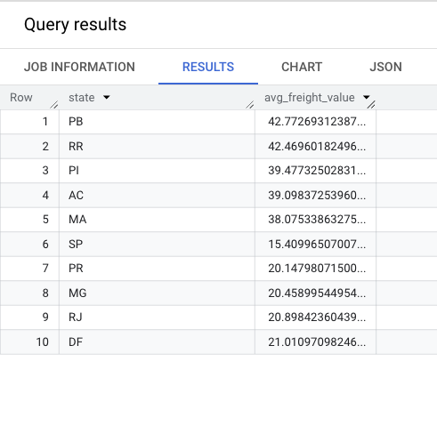

**3.Find out the top 5 states with the highest & lowest average delivery time.**

WITH high_low as (

SELECT

geo.geolocation_state as state,

AVG(DATE_DIFF(ord.order_estimated_delivery_date, ord.order_delivered_customer_date, day)) as diff_estimated_delivery

FROM `TARGET_SQL.orders` AS ord

JOIN `TARGET_SQL.customers` AS cust

ON ord.customer_id = cust.customer_id

JOIN `TARGET_SQL.geolocation` AS geo

ON cust.customer_zip_code_prefix = geo.geolocation_zip_code_prefix

GROUP BY geo.geolocation_state

)

(SELECT state, diff_estimated_delivery

FROM high_low

ORDER BY diff_estimated_delivery DESC

LIMIT 5)

UNION ALL

(SELECT state, diff_estimated_delivery

FROM high_low

ORDER BY diff_estimated_delivery ASC

LIMIT 5)

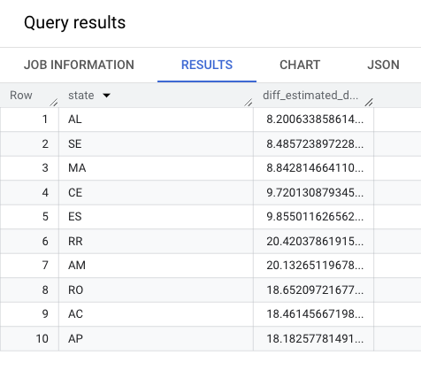

**4. Find out the top 5 states where the order delivery is really fast as compared to the estimated date of delivery.  
You can use the difference between the averages of actual & estimated delivery date to figure out how fast the delivery was for each state.**

with top_five as (

SELECT

geo.geolocation_state as state,

AVG(DATE_DIFF(ord.order_estimated_delivery_date, ord.order_purchase_timestamp, day)) as est_date,

AVG(DATE_DIFF(ord.order_delivered_customer_date, ord.order_purchase_timestamp, day)) as delivered_date

FROM `TARGET_SQL.orders` AS ord

JOIN `TARGET_SQL.customers` AS cust

ON ord.customer_id = cust.customer_id

JOIN `TARGET_SQL.geolocation` AS geo

ON cust.customer_zip_code_prefix = geo.geolocation_zip_code_prefix

GROUP BY geo.geolocation_state

)

select top_five.state, top_five.delivered_date

from top_five

where top_five.delivered_date < top_five.est_date

ORDER BY top_five.delivered_date DESC

limit 5

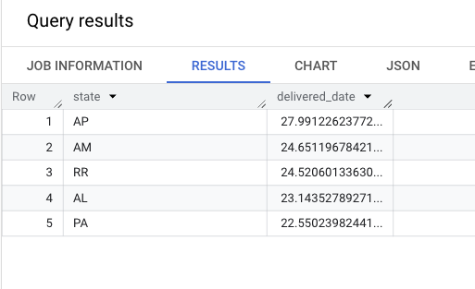

------------------------------------------------------------------------------------------------------------------------------------------------------

**Analysis based on the payments**

**1. Find the month on month no. of orders placed using different payment types.**

SELECT pmt.payment_type,

EXTRACT(YEAR FROM ord.order_purchase_timestamp) AS year_x,

EXTRACT(MONTH FROM ord.order_purchase_timestamp) AS month_x,

COUNT(pmt.order_id) AS order_count

FROM `TARGET_SQL.payments` AS pmt

JOIN `TARGET_SQL.orders` AS ord

ON pmt.order_id = ord.order_id

GROUP BY pmt.payment_type ,EXTRACT(YEAR FROM ord.order_purchase_timestamp), EXTRACT(MONTH FROM ord.order_purchase_timestamp)

ORDER BY pmt.payment_type, year_x, month_x

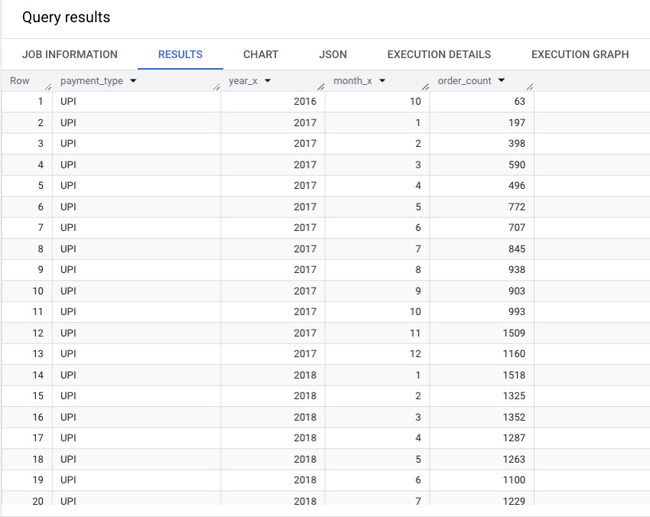

**2. Find the no. of orders placed on the basis of the payment installments that have been paid.**

SELECT payment_type, COUNT(DISTINCT order_id) AS order_count

FROM `TARGET_SQL.payments`

WHERE payment_installments > 0

GROUP BY payment_type

